Shop Inventory of main items
Item 1 GWR Starter Train Set £ 95
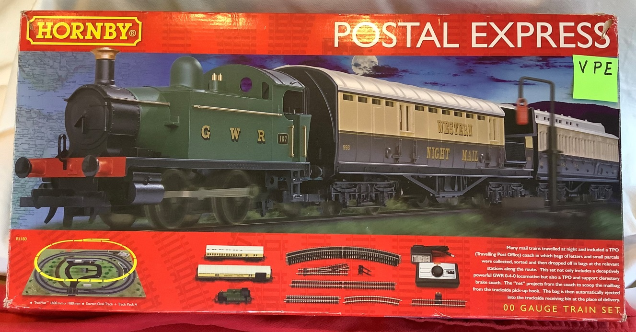
Complete Hornby mail train starter set. GWR tank loco, mail coach and accessories, passenger coach, controller, loop of track. Ideal beginners set which can be added to.

Item 2 LMS Starter Set £ 95
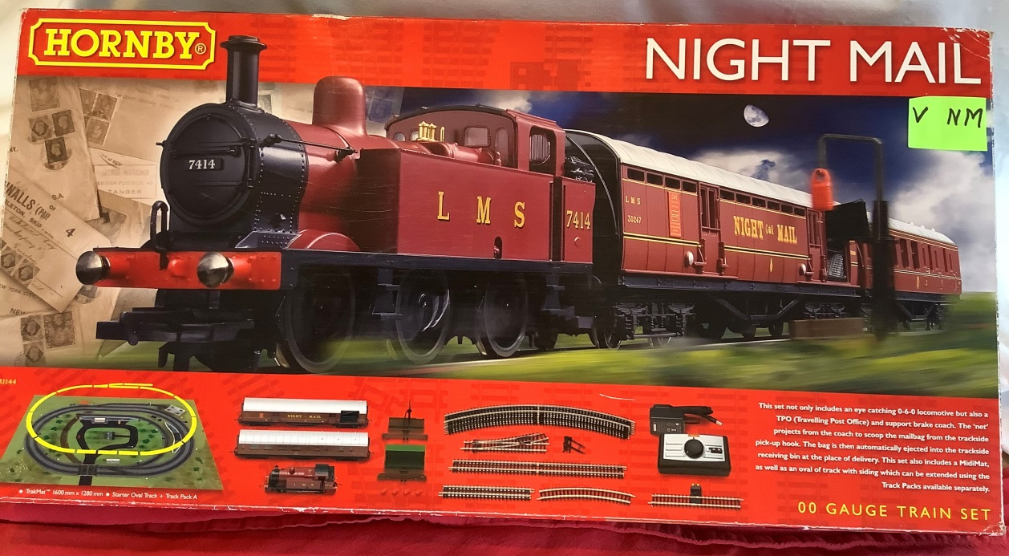

Complete Hornby mail train starter set. LMS tank loco, mail coach and accessories, passenger coach, controller, loop of track.Ideal beginners set which can be added to.
Item 3 Apple Pencil A1603 £ 50

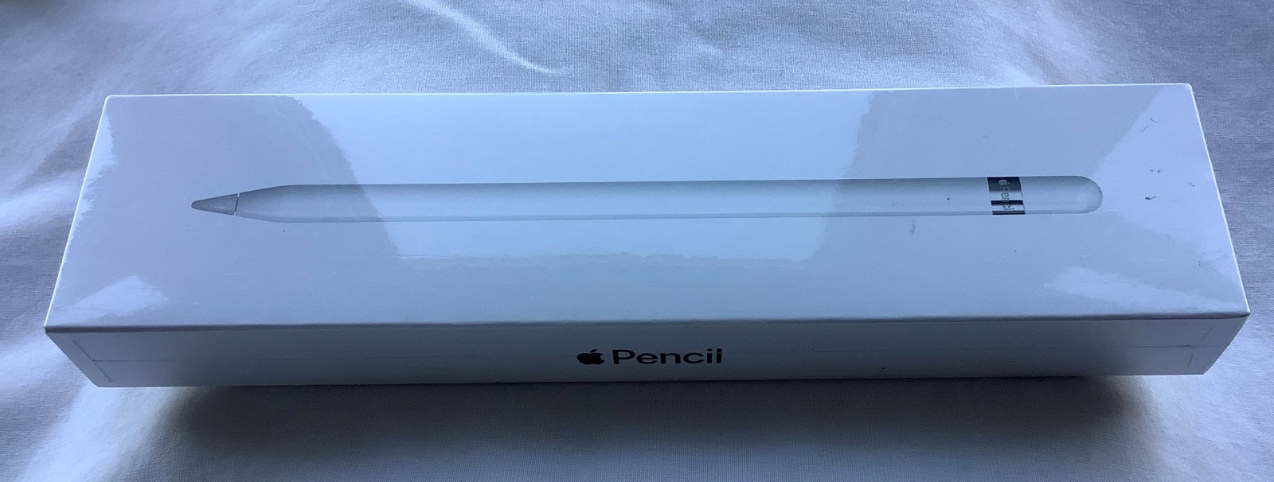
Apple Pencil model A 1603. MKOC2ZM/A.
In unopened box and never used.

Item 5 Scalextric Racing Set £ 25

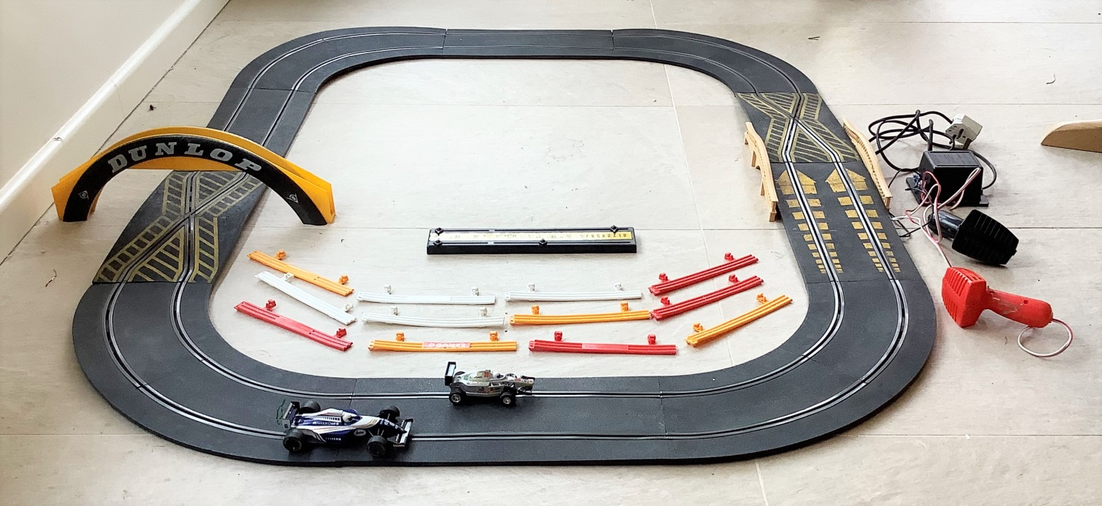
Used original Scalextric car racing set. Basic layout with two formula 1 racing cars plus two cross – overs, hump back bridge, Dunlop over bridge, side fencing and lap timers. Extra cars available if required plus some spare track lengths.
Item 6 Hornby Virgin Pendolino 4 Coach set £ 90
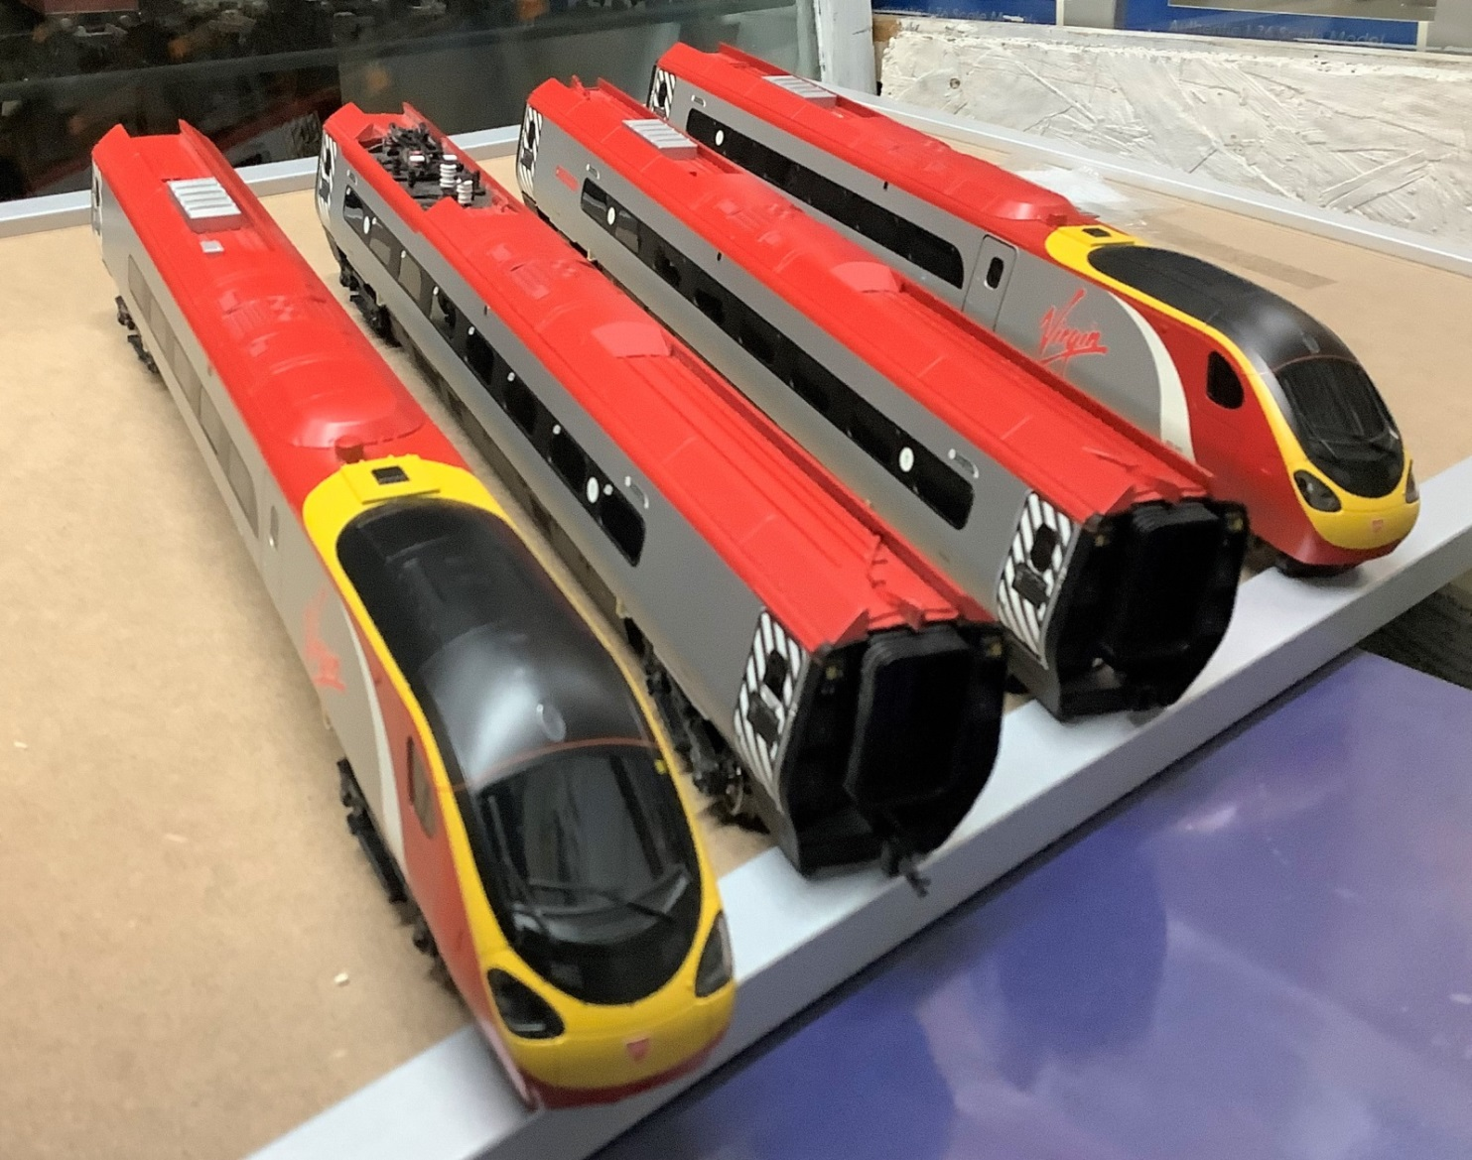

In addition to the Starter sets and Loco set above, we have a range of all types of 00 gauge locos at prices from £ 15 upwards.

Item 7 Hornby 9F loco £ 85

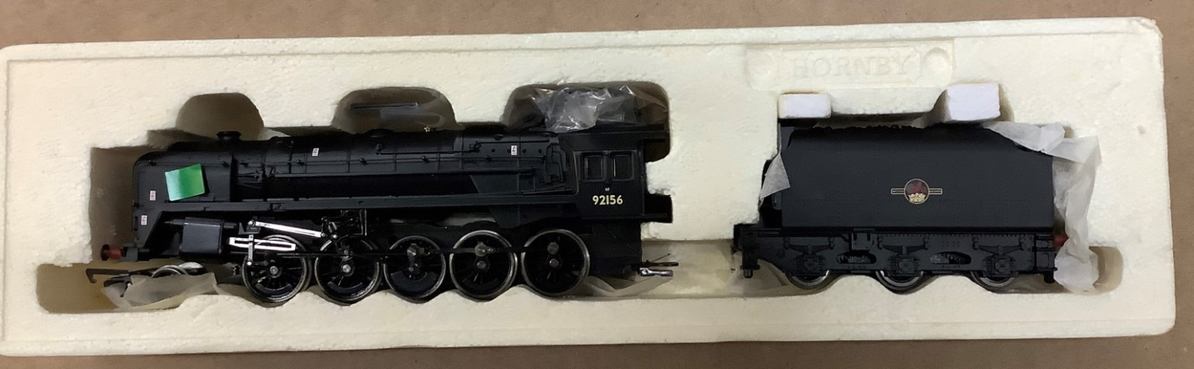
Item 8 Bachmann Thompson B1 loco £ 65
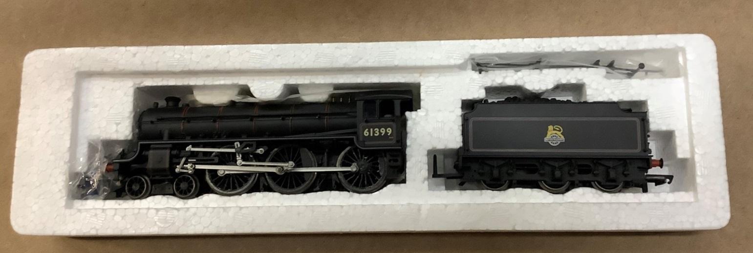

Item 9 Hornby Britannia loco £ 75
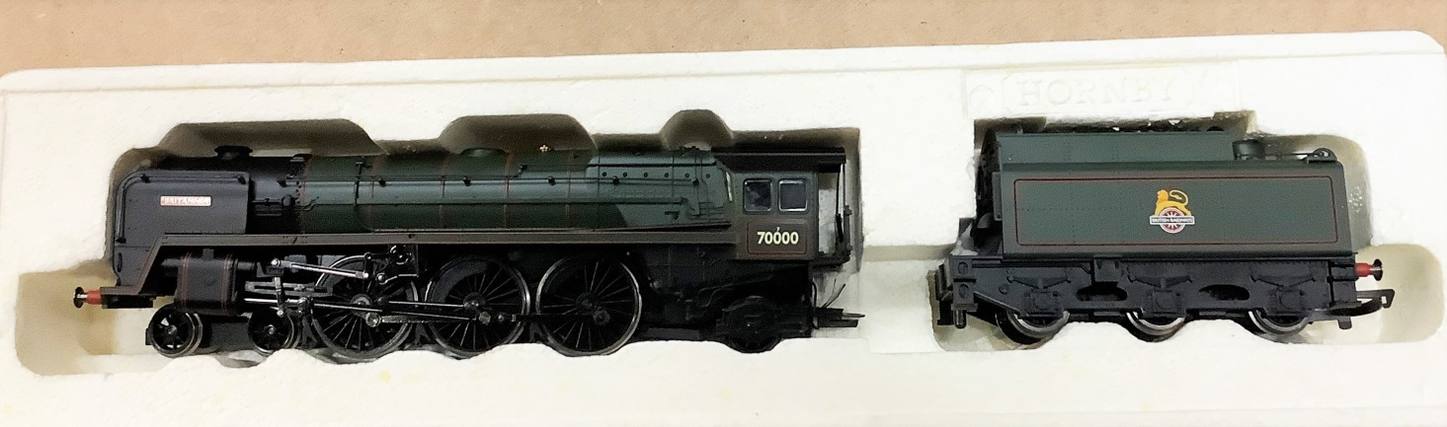

Item 10 Hornby Class 56 loco £ 50
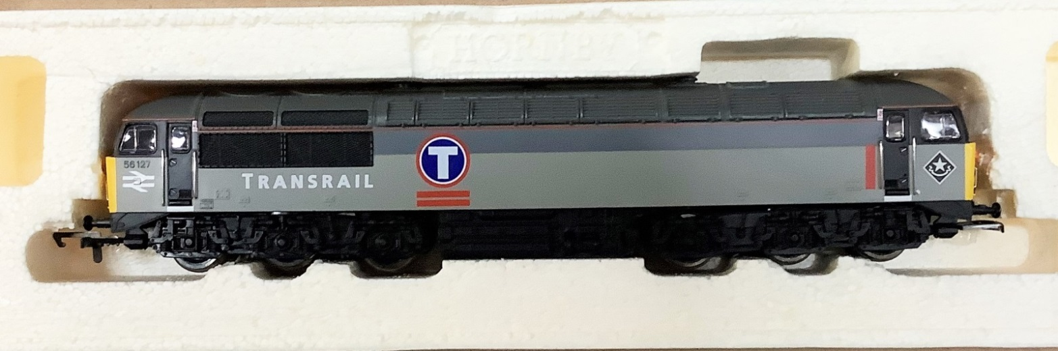

Item 11 Class 59 loco DCC Ready £ 75
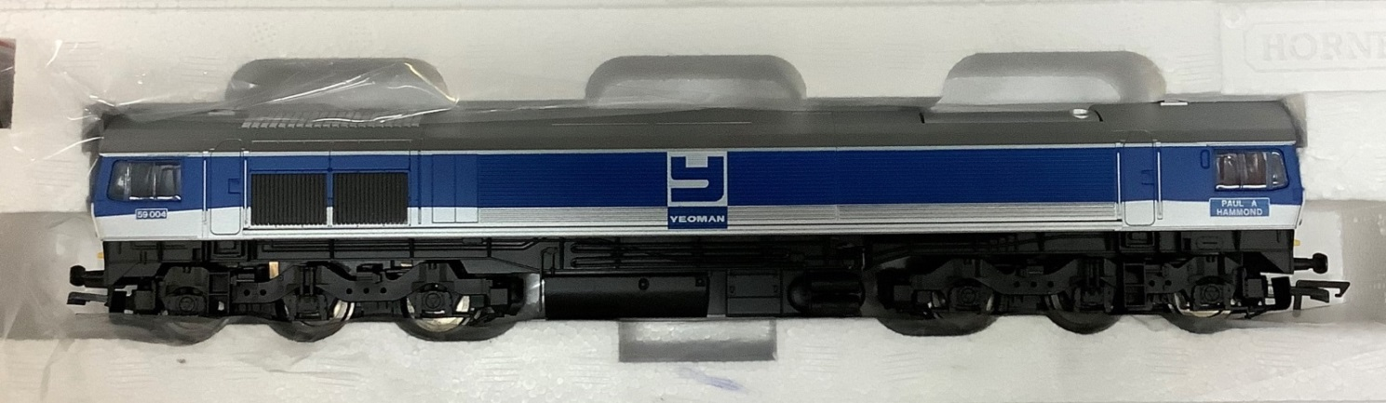

Item 12 Hornby County class loco £ 45
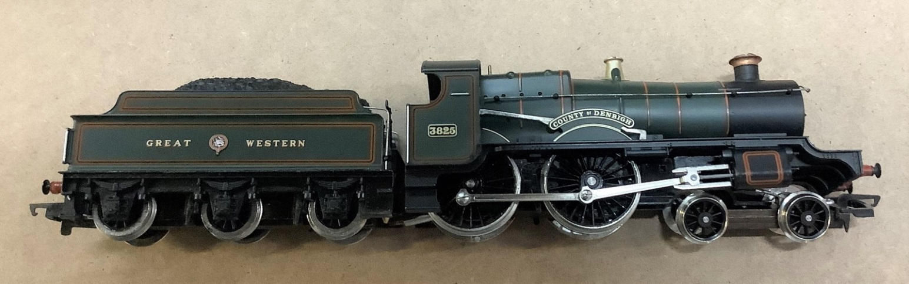

Item 13 Hornby Flying Scotsman £ 75
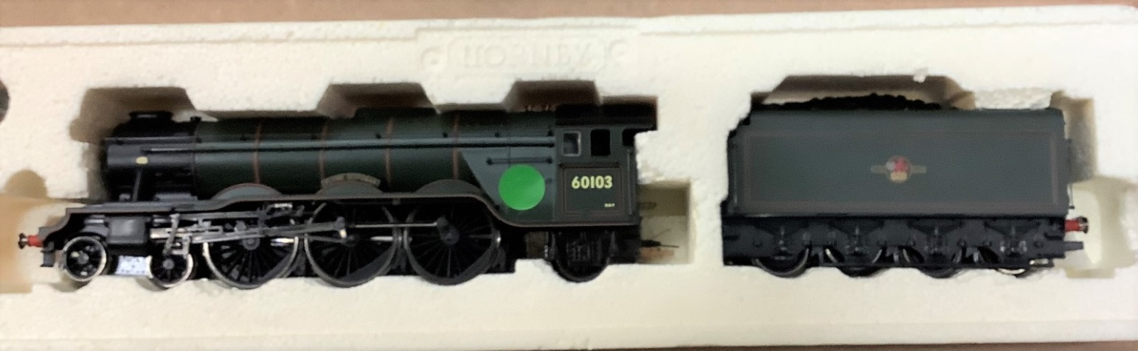
Item 14 Bachmann Gresley J39 loco £ 65
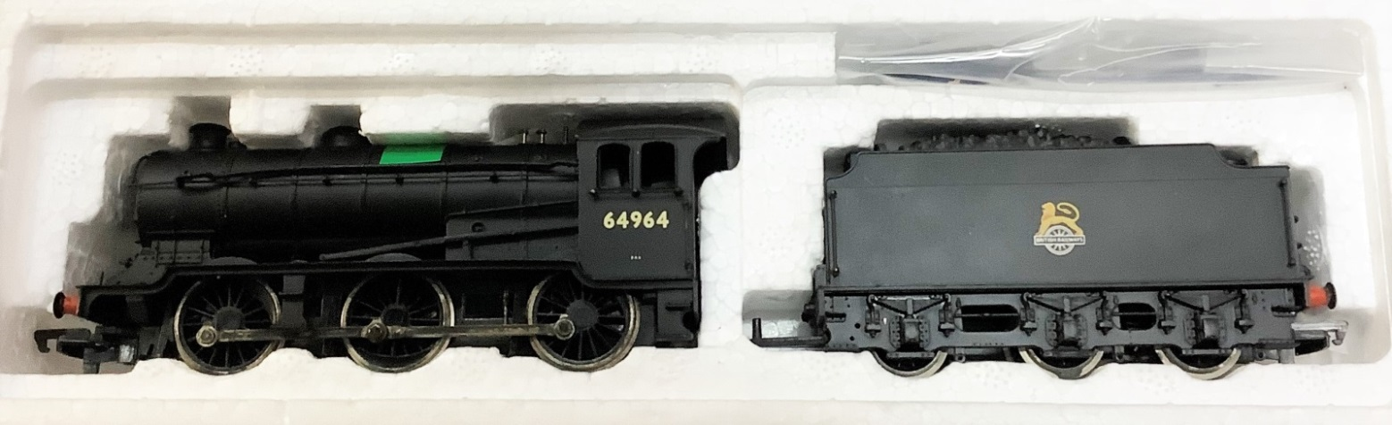

Item 15 Hornby J94 loco - weathered £ 65
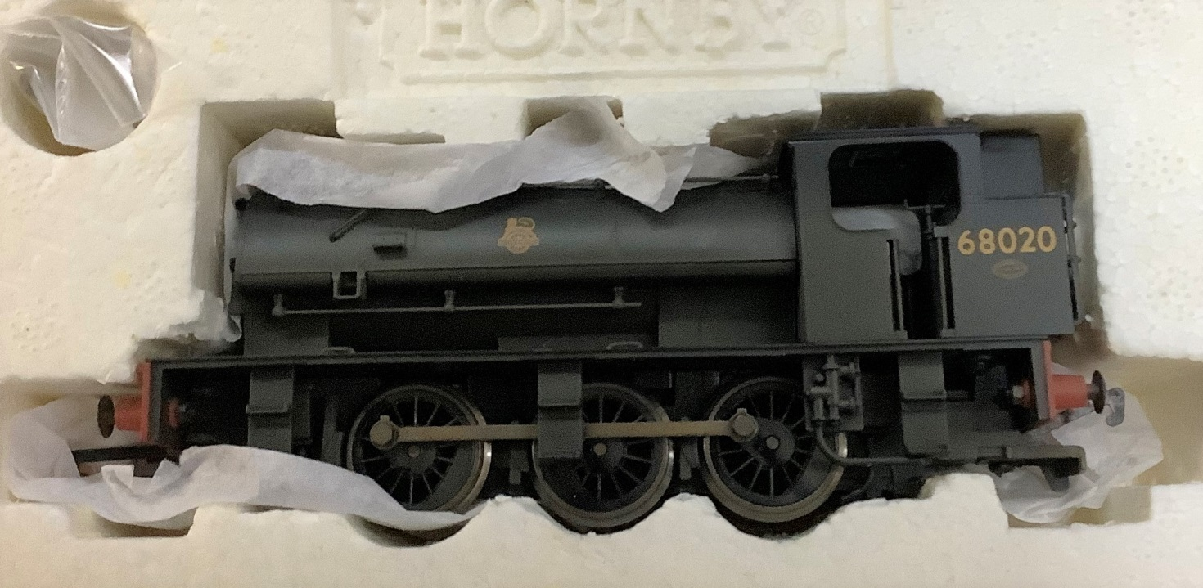

Item 16 Lima Crab loco £ 45
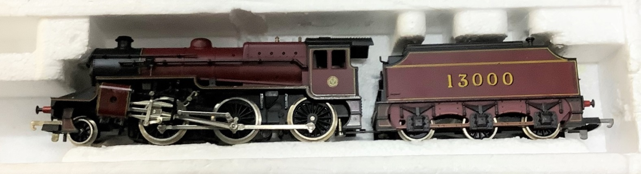

Item 17 Replica B1 loco £ 50
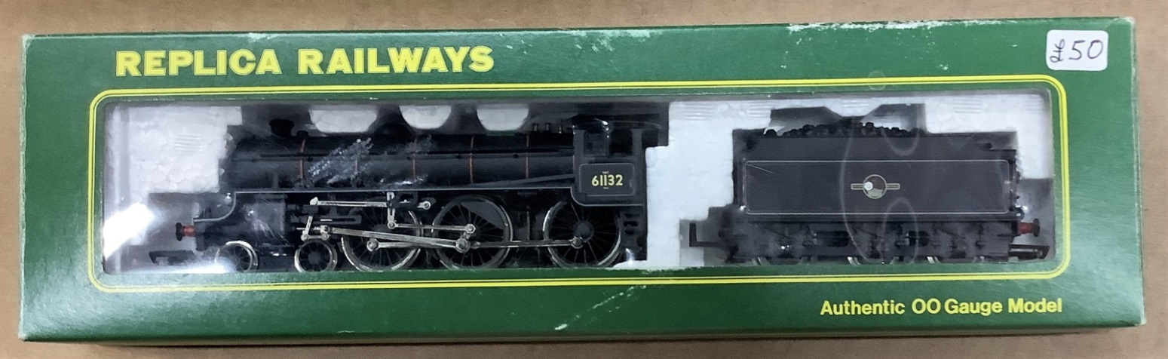

Item 18 Hornby King Arthur loco £ 90
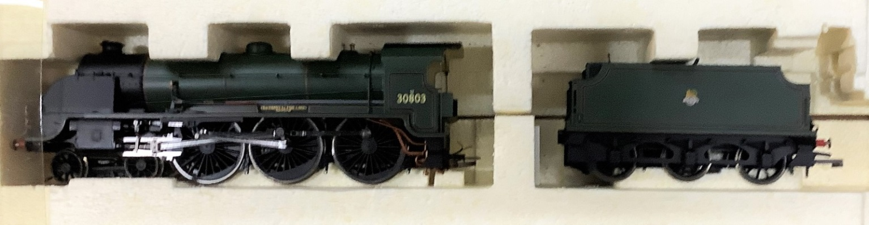

Item 19 Bachmann V1 tank loco £ 75
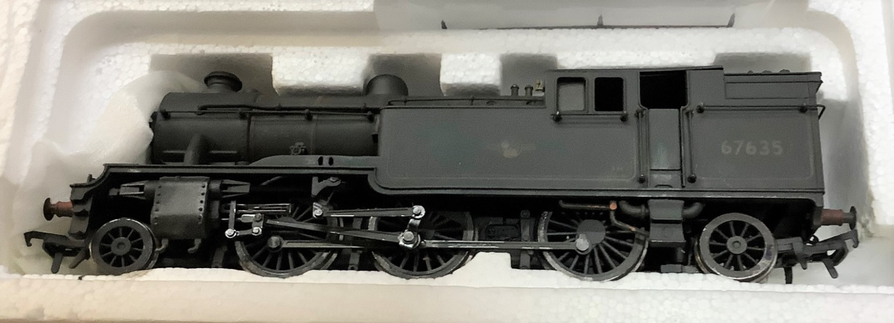

Item 20 Bachmann V2 loco £ 60
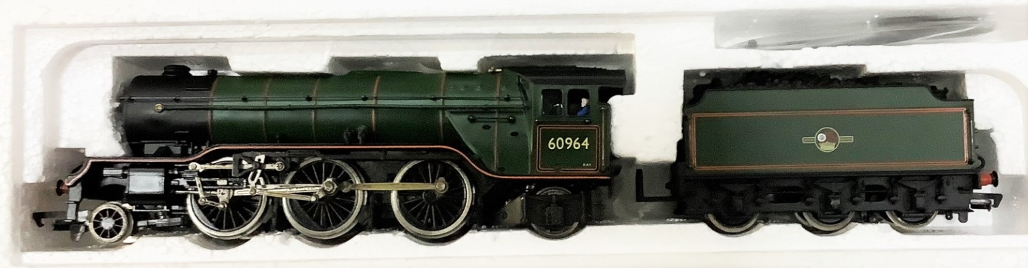

Item 21 Bachmann (Thomas Group) Emily £ 125
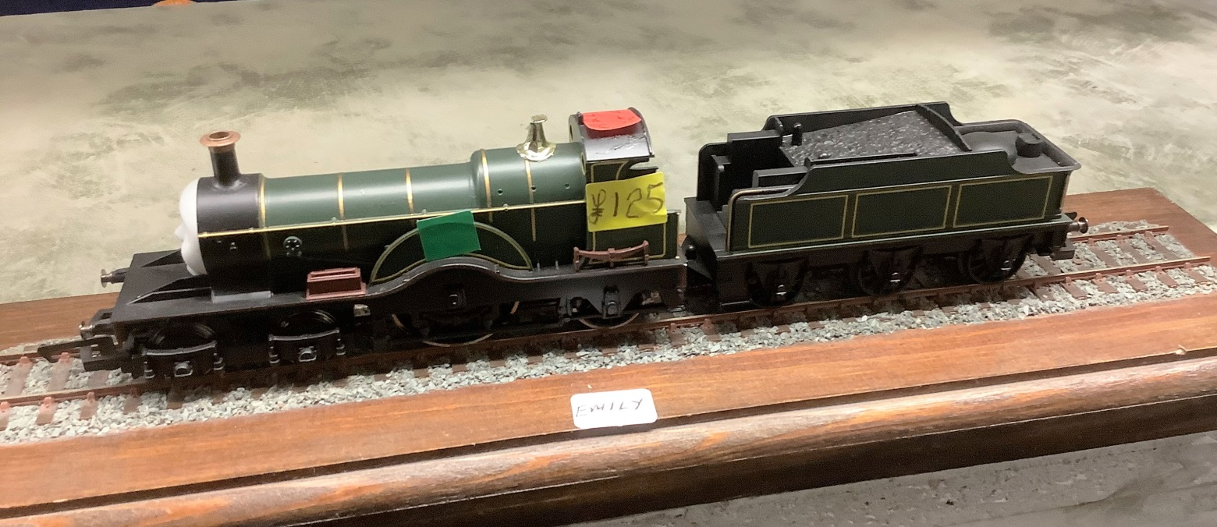

Note There is some damage to the loco dome

…..and of course we couldn’t end without an example of the best steam loco in the world.

Biased ……. Of course we are !!!!

Item 22 Bachmann Std 4 mt tank loco £ 85
